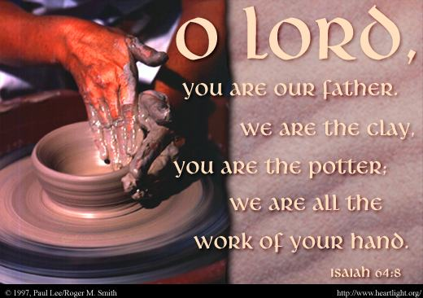
Morning Dedication to the Potter

As I rise from night’s rest,
I direct my first thoughts to my Father Potter.
Shape me upon your wheel this day;
Mold me fully into the image of Jesus.
May my outer clay be made transparent
to shine forth the Gospel treasure that lies within.
Make my mouth pour forth only
sweet thanks and precious wisdom.
May my attractiveness be the beauty of Your grace
and my use be honorable with the goal of Your glory.

Let those around see me living by Your Spirit,
trampling the world underfoot,
unconformed to worthless lies,
transformed by a renewed mind,
shining as a never-dimmed light,
showing holiness in all my doings.

May I travel mucky paths with a life pure from spot or stain.
Let my affection be in heaven,
and my love soar upwards in flames of fire,
my gaze fixed on unseen things,
my eyes open to the emptiness, fragility,
mockery of earth and its vanities.

May I view all things in the clear mirror of eternity,
waiting for the coming of my Lord,
listening for the last trumpet call,
hastening unto the new heaven and earth.

May I speak each word as if my last word,
and walk each step as my final one.
If my time upon the wheel is done −
if my life should end today,
O Father Potter,
let this be my best day!

− Valley of Vision, p. 119 with additions.

